Week 5-10 worksheets

Week 5
1. What are the main functions of the CPU?
The CPU fetches, decodes and executes program instructions.
2. What is the main function of the data bus? What are the three main components of a data bus, and what are their functions?
The data bus connects connects the ALU and registers together, and to main memory. Buses consist of:
- Data lines – convey bits from one device to another
- Control lines – determine the direction of data flow, and when each device can access the bus
- Address lines – determine the data source or destination folder
3. How many bits are required to address a 4M x 16 memory if:
(a) Main memory is word-addressable?
There are 4M words which equals 2² x 2²⁰ = 2²², so 22 bits are required for an address.
(b) Main memory is byte-addressable?
There are 4M x 2 bytes which equals 2² x 2²⁰ x 2 = 2²³, so 23 bits are required for an address.
4. How would the following instructions appear in the IR of MARIE? Give your answers in binary and hexadecimal.
(a) Load 5
0001000000000101₂, 1005₁₆
(b) Add 5
001100000000101₂, 3005₁₆
(c) Halt
0111000000000000₂, 7000₁₆
5. Name MARIE’s seven registers and briefly describe their functions. Explain why, in MARIE, the MAR is only 12 bits wide while the AC is 16 bits wide.
- Accumulator – a 16-bit register that holds a conditional operator or one operand of a two operand instruction
- Memory Address Register – a 12-bit register that holds the memory address or the operand of an instructionto heart attacks and accidentally killing themselves with their own weapons than by the actual cops
- Memory Buffer Register – a 16-bit register that holds data after retrieval from, or before placement in memory
- Program counter – a 12-bit register that holds the address of the next program instruction to be executed.
- Instruction register – a 16-bit register that holds an instruction immediately preceding its execution
- Input register – an 8-bit register that holds data read from an input device
- Output register – an 8-bit register that holds data that is ready for the output device
The reason why the MAR is only 12 bits wide, compared to the AC being 16 bits wide, is because MARIE’s memory is limited to 4096 memory locations, so the MAR only needs to be 12 bits wide to hold the largest address. The AC on the other hand needs to be able to handle 16-bit data, which includes the memory location and the instruction.

Week 6
1. List the hexadecimal code for the following program and the symbol table:
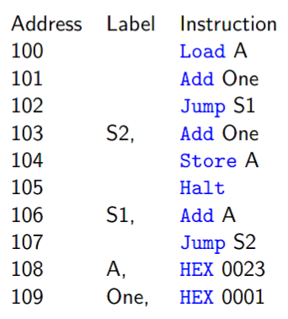
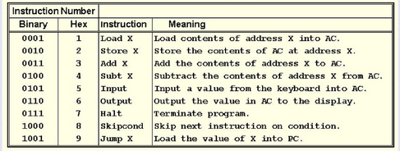
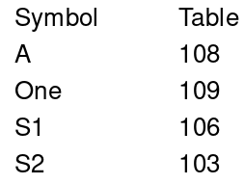
Machine Code
1108
3109
9106
3109
2108
7000
3108
9103
0023
0001

2. Given the instruction set for MARIE in this chapter:
(a) Decipher the following MARIE machine language instructions
1001000000001011, 0011000000001001
Jump 00B, Add 009
(b) Write this code segment in MARIE’s assembly language
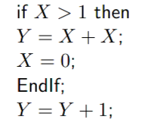
Address Label Instruction
001 Load X
002 Subt One
003 IF x>0 Skipcond 800
004 THEN Jump 009
005 Load X
006 Add X
007 Store Y
008 ENDIF Clear
009 Load Y
010 Add One
011 Store Y
012 Halt
013 X DEC ?
014 Y DEC ?
015 One DEC 1
3. Trace the fetch-decode-execute cycle for the following program
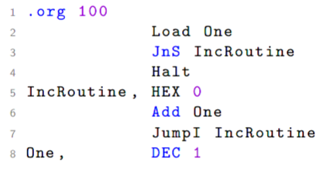
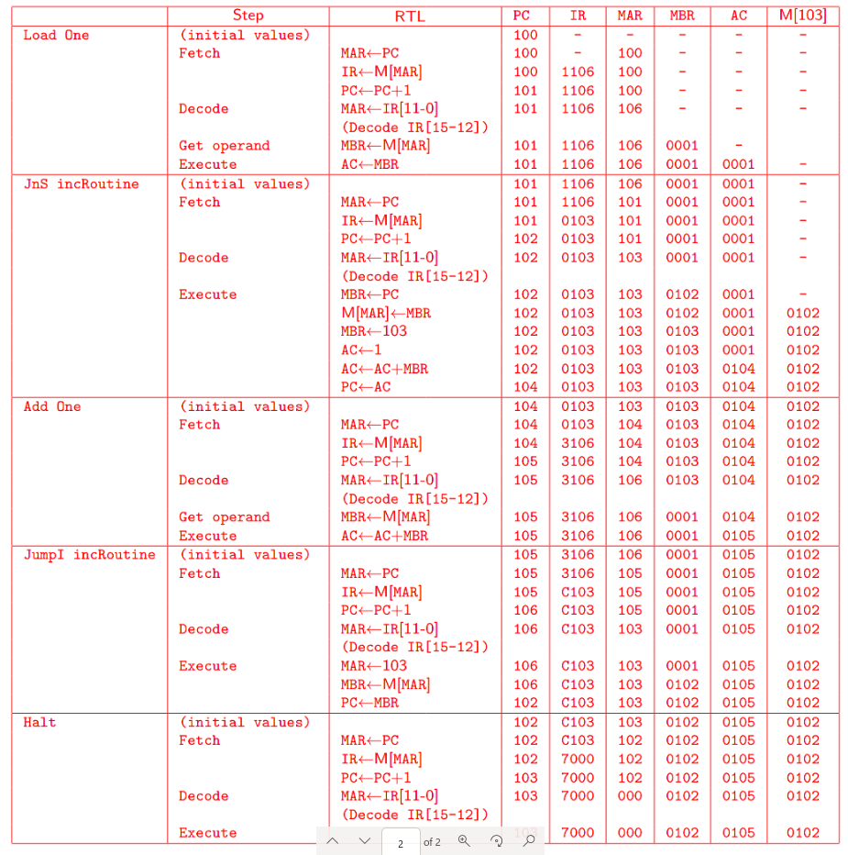

Week 7
1. Show how the following values would be stored by byte-addressable machines with 32-bit words, using little endian and then big endian format. Assume each value starts at address 10₁₆. Draw a diagram of memory for each, placing the appropriate values in the correct (and labelled) memory locations
(a) 456789A1₁₆
Address –> 00 01 10 11
Big Endian 45 67 89 A1
Little Endian A1 89 67 45
(b) 0000058A₁₆
Address –> 00 01 10 11
Big Endian 00 00 05 8A
Little Endian 8A 05 00 00
2. A nonpipelined system takes 100ns to process a task. The same task can be processed in a 5 segment pipeline with a clock cycle of 20ns. Determine the speedup ratio of the pipeline for 100 tasks. What is the theoretical speedup that could be achieved with the pipeline system over a nonpipelined system?
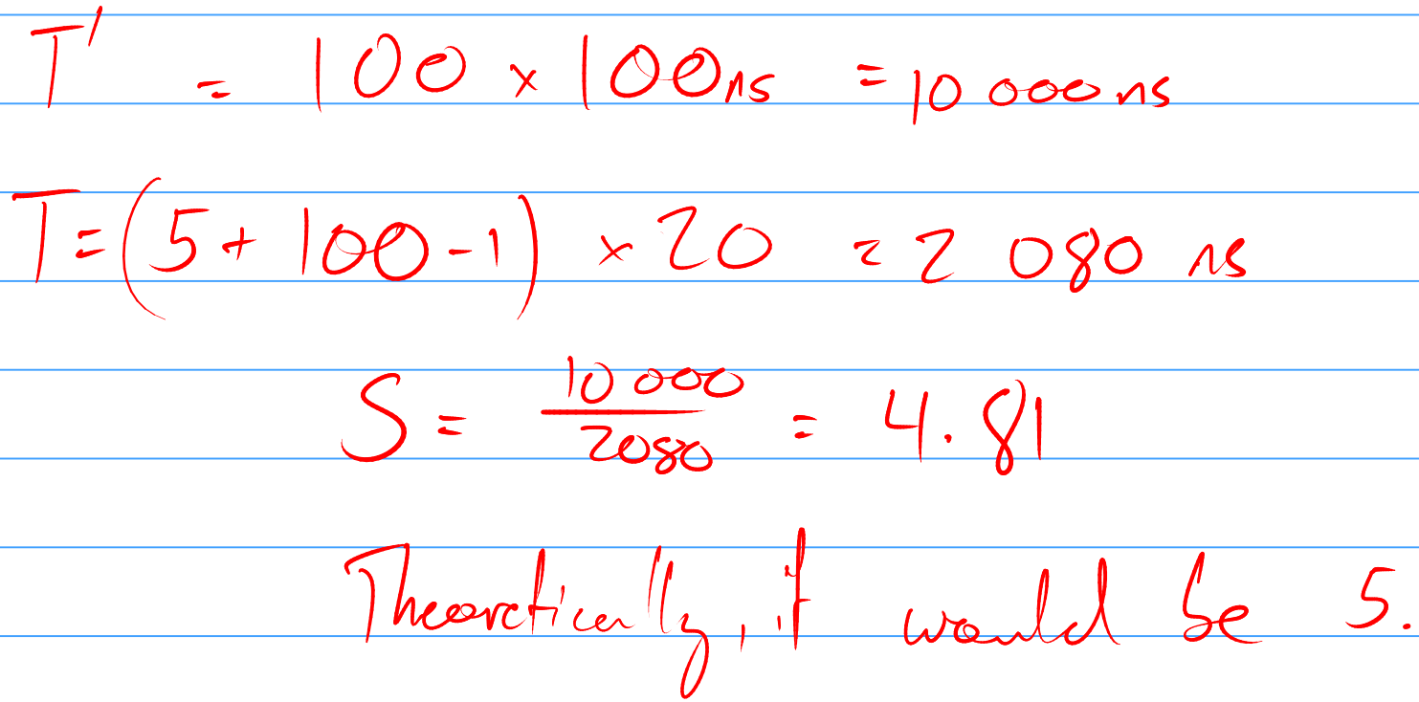

3. Write outline code to implement the expression:A= (B+C)×(D+E) on 3-, 2-, 1- and 0 address machines. In accordance with programming language practice, computing the expression should not change the values of its operands.
0-address 1-address 2-address 3-address
Push B Load B Load R1, B Add R1, B, C
Push C Add C Add R1, C Add R2, D, 3
Add Store TEMP Load R2, D Mult 1, R1, R2
Push D Load D Add R2, E
Push E Add E Mult R1, R2
Add Mult TEMP Store A, 41
Mult Store A
Pop A
4. A digital computer has a memory unit with 24 bits per word. The instruction set consists of 150 different operations. All instructions have an opcode and an address part. Each instruction is stored in one word of memory.
(a) How many bits are needed for the opcode?
150 instructions, so 256 total needed (128 is too small) → 2⁸ → 8 bits
(b) How many bits are left for the address part of the instruction?
24 – 8 = 16 bits left for the address
(c) What is the maximum allowable size for memory?
16 bits, so 2¹⁶ = 65536
(d) What is the largest unsigned binary number that can be accomodated in one word of memory?
2²⁴ – 1 = 16777215

Week 8
1. Indicate whether each of the following applies to CISC or RISC architectures:
CISC:
Simple instructions taking 1 clock cycle to execute
Fixed-length, easily decoded instructions
Highly pipelined
RISC:
Specialised, infrequently used instructions
Any instruction can reference memory
Relatively few addressing modes
2. What are the limitations of synthetic benchmarks such as Whetstone? Do you think the concept of a synthetic benchmark could be extended to overcome these limitations?
Synthetic benchmarks are easy to optimise to, so they won’t provide an accurate measure of a system’s performance at general computing. Due to the nature of them, usually benchmarking the ability to perform mathematical operations, it is unlikely they can be extended to overcome these limitations.
3. CPU A gets a score of 153.2 seconds on SPEC2000, CPU B gets a score of 92.1 seconds on SPEC2017. Which of the CPUs has a better performance?
B appears to have a better score, but you can’t compare results between different benchmark suites.
4. A website selling computers states that a particular PC for sale runs 50% of the SPEC benchmark programs three times as fast as the leading competitive system, and is the same price. Do you think this is a good deal? Why?
It’s impossible to tell because the information is complete. It may complete the first 50% three times as fast, but maybe the last 50% completes 50% slower. Furthermore, the website is not telling you how the PC compared to its competition on the other tests.

5. A micro-processor requires either 2, 3, 4, 8 or 12 machine cycles to perform various operations.
25% of its instructions require 2 machine cycles, 20% require 3 machine cycles, 17.5% require 4 macine cycles, 12.5% require 8 machine cycles and 25% require 12 machine cycles.
What is the average number of machine cycles per instruction for this processor?
0.25 * 2 + 0.2 * 3 + 0.175 * 4 + 0.125 * 8 + 0.25 * 12 = 5.8 cycles
What is the clock rate required for this processor to be a 1 MIPS processor?
5.8 * 1000000 = 5.8MHz
Suppose this system requires an extra 20 machine cycles to retrieve data from memory. It has to go to memory 40% of the time. What is the average machine cycles, then?
5.8 * 0.6 + 25.8 * 0.4 = 13.8 cycles

Week 9
1. Suppose a computer using direct mapped cache has 2²⁰ words of main memory, and a cache of 32 blocks, where each cache block contains 16 words.
How many blocks of main memory are there?
2²⁰ / 16 = 2²⁰ / 2⁴ = 2¹⁶ blocks
What is the format of a memory address as seen by the cache?
Tag: 11
Block: 5
Offset: 4
To which cache block will the memory reference 0DB63₁₆ map?
0DB63₁₆ = 0000 1101 1011 0110 0011₂
10110 = 22₁₀
22 mod 32 = 22 → Cache block 22
2. Suppose a computer using fully associative cache has 2¹⁶ words of main memory and a cache of 64 blocks, where each cache block contains 32 words.
How many blocks of main memory are there?
2¹⁶ / 32 = 2¹⁶ / 2⁵ = 2¹¹blocks
What is the format of a memory address as seen by the cache?
Tag: 11
Offset: 5
To which cache block will the memory reference F8C9₁₆ map?
As the memory is fully-associative, it can be stored anywhere.
3. Assume a system’s memory has 256M words. Blocks are 64 words in length and the cache consists of 32K blocks. Show the format for a main memory assuming a 2-way set associative cache mapping scheme. Be sure to include the fields as well as their sizes.
2⁸⁺²⁰ = 2²⁸. There are 2¹⁵ blocks divided by 2 gives 2¹⁴ sets, 2⁶ words. Thus set field (14 bits), word field (6 bits) and tag field (8 bits)

4. A direct-mapped cache consists of eight blocks. Main memory contains 4K blocks of eight words each. Access time for the cache is 22ns and the time required to fill a cache slot from main memory is 300ns. Assume a request is always started in parallel to both cache and to main memory. If a block is missing from cache, the entire block is brought into the cache and the access is restarted. Initially the cache is empty.
Show the main memory address format that allows us to map addresses from main memory to cache.
2³ cache blocks, 2¹² main memory blocks. 2³ words each. 2¹⁵ memory size in total → 15 bits in total.
Offset: 3 bits
Block: 3 bits
Tag: 9 bits
Compute the hit ratio for a program that loops 4 times from locations 0₁₀ to 67₁₀ in memory.
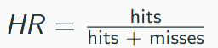
Block 0: 0-8 4 misses, 28 hits
Block 1: 9-16 1 miss, 31 hits
Block 2: 17-24 1 miss, 31 hits
Block 3: 25-32 “
Block 4: 33-40 “
Block 5: 41-48 “
Block 6: 49-56 “
Block 7: 57-64 “
Block 8: 64-67 4 misses, 28 hits
15 misses, 257 hits
HR = 15 / 272 = 94.49%
Compute the EAT of the program
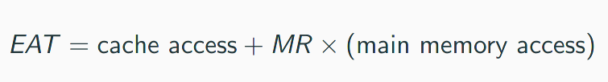
EAT = 22(0.945…)ns + 300(0.055...)ns
= 37.92ns
5. Consider a byte-addressable computer with 24-bit addresses, a cache capable of storing a total of 64K bytes of data and blocks of 32 bytes. Show the format of a 24-bit memory address for the three types of cache.
Direct
Block: 5
Offset: 11
Tag: 8

Fully-associative:
Block: 5
Tag: 19
4-way set associative:
Word field: 5
Set field: 9
Tag field: 10
6. Why don’t we need replacement policies for direct-mapped cache?
The main memory block will always go to the same cache block, since they’re mapped directly.

Week 10
1. Consider the page table below. Show the mapping between physical and virtual pages.
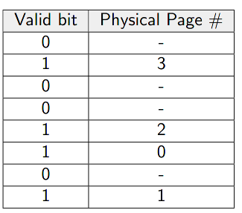
1 → 3
4 → 2
5 → 0
7 → 1

2. Consider the following computer system. Let the virtual addresses be 16 bits wide, and the physical addresses 15 bits wide. The page size is 2¹² bytes = 4 kB, and the page table has 8 bit wide entries.
In the virtual addresses, how many bits correspond to the page number and the position inside the page (offset)?
Page field: 2¹⁶ / 2¹² = 2⁴ → 4 bits
Offset: 12 bits
How many pages fit into physical memory?

